2005 Joint WRF/MM5 User’s Workshop, 19-22 June 2006, Boulder, Colorado, United States

NUMERICAL SIMULATION OF POLAR LOW DEVELOPMENT OVER THE JAPAN SEA USING THE WRF MODEL

H. Kusaka¹, S. Kataniwa¹, H. L. Tanaka¹, F. Kimura¹, and M. Hara²

¹ Graduate School of Life and Environmental Sciences, University of Tsukuba, Tsukuba, JAPAN
² Frontier Research Center for Global Change (FRCGC), Japan Agency for Marine-Earth Science and Technology (JAMSTEC), Yokohama, JAPAN

1. INTRODUCTION

Many polar lows have been observed in the Japan Sea (e.g., Ninomiya 1991). Polar low developing over this region sometimes causes natural disaster and thus more accurate simulation and prediction are required. Most of the earlier simulations of the Japan Sea polar low were done for the period of 1-2 days from the formation stage. In this study, we simulate a polar low that formed and developed over the Japan Sea on December 4-5, 2005 (Figures 1 and 2). This polar low is larger than the averaged one that normally develops over this region.

2. NUMERICAL SIMULATION OF POLAR LOW OVER THE JAPAN SEA

2.1. DESIGN OF NUMERICAL SIMULATION

We expect that the WRF model will be more useful tool to simulate and predict mesoscale phenomenon than a current mesoscale model such as MM5 (e.g., Kusaka et al. 2005). In the present study, we run the WRF model for 72 hours beginning at 09 JST December 3, 2005. The horizontal grid spacing of the outer and inner domains is 30 and 10 km, respectively. For both domains, 31 sigma levels are set in the vertical. The model dynamics is ARW core. The physical parameterizations are Dudhia showtwave radiation, RRTM longwave radiation, WSM3 cloud microphysics, YSU planetary boundary layer, and slab land surface schemes. The initial and boundary conditions are derived from the NCEP-FNL data.

2.2. RESUTS

Figure 3 shows the spatial distribution of the sea level pressure. It clearly indicates that the WRF simulates the polar low from the formation to mature stages well. Additionally the location of the polar low is almost correct at the mature stage. Figures 4a and 4b indicate the temperature field at 700 hPa level derived from the JMA mesoscale analysis data with 10-km horizontal grid spacing and the present simulation, respectively. The comparison between two figures shows that the simulated polar low makes warm core and does not bring the front, which are the essential features of the polar low. Moreover, the WRF model simulates vortex as shown in Figure 5. From these, we could conclude that the WRF model successfully simulated the present polar low event.

3. SUMMARY

Polar low event over the Japan Sea was simulated by the WRF Advanced Research version. The WRF model simulated the polar low from the formation to mature stages well. In addition to that the essential features of the polar low such as warm core and spiral bands were also represented well. This could conclude the 10-km WRF has a good performance to simulate the polar low over the Japan Sea. At present, we perform an additional simulation, where the cumulus parameterization scheme is not used. Effects of the surface fluxes, terrain, and large-scale thermal, moisture, and dynamic conditions will be investigated by the sensitivity experiments in the near future.

REFERENCES

Kusaka, H., A. Crook, J. Dudhia, and K. Wada, 2005b: Comparison of the WRF and MM5 models for simulation of heavy rainfall along the Baiu front. SOLA, 1, 197-200.

Ninomiya, K., 1991: Polar low genesis over the east coast of the Asian continent simulated in an AGCM, J. Meteor. Soc. Japan, 81, 697-712

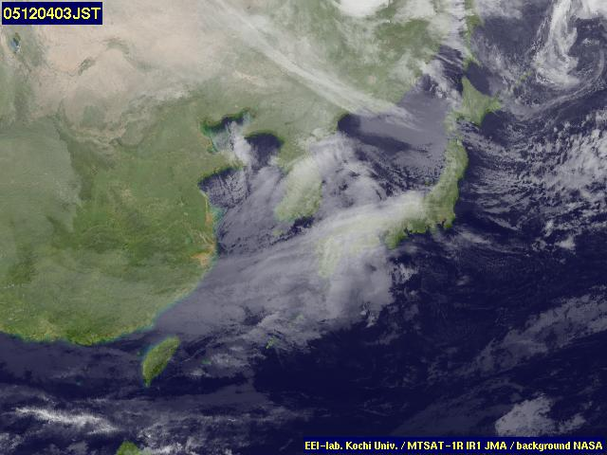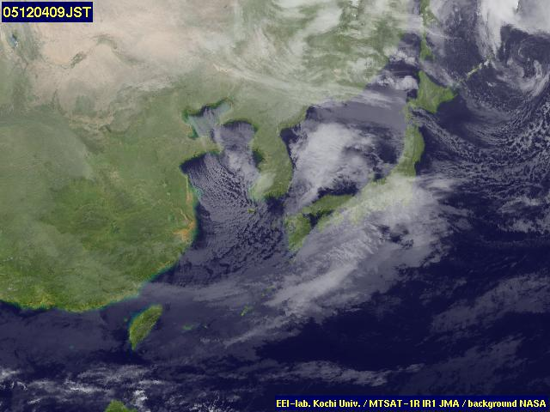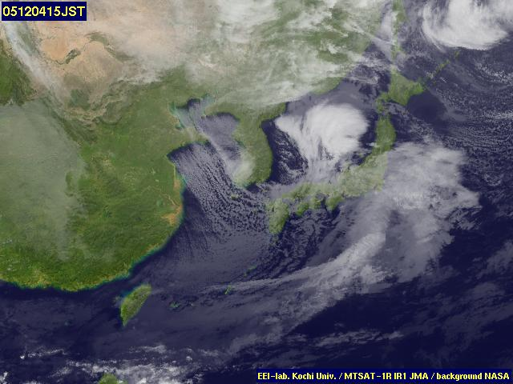

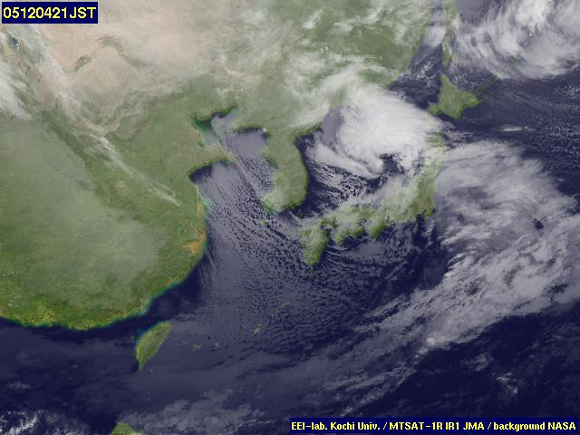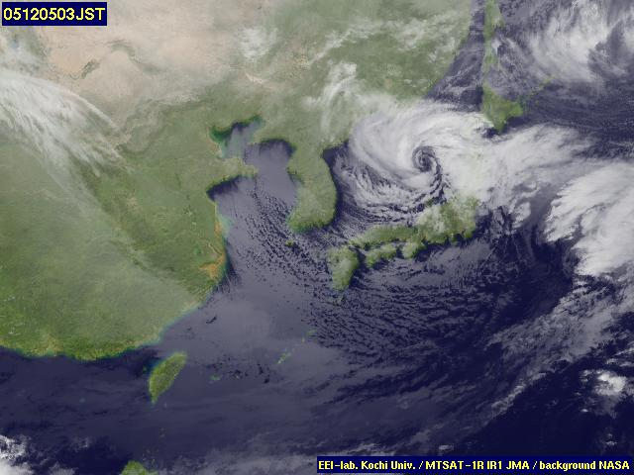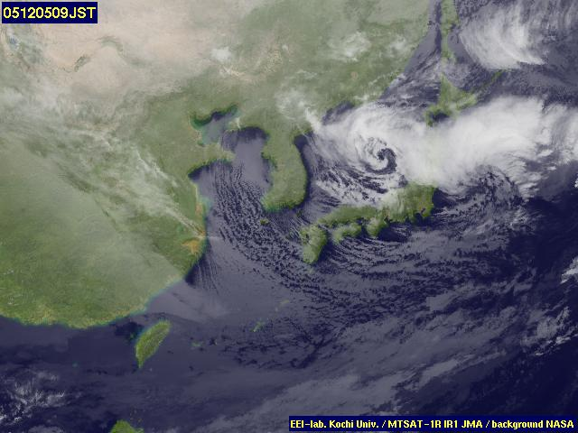

Figure 1. Cloud (Satellite infrared) image at (a) 2005-12-04 03 JST, (b) 2005-12-04 09 JST, (c) 2005-12-04 15 JST, (d) 2005-12-04 21 JST, (e) 2005-12-05 03 JST, and (f) 2005-12-04 09 JST. (from Kochi Univ., Univ. Tokyo, and JMA).

Figure 2. Surface weather map at (a) 2005-12-03 09 JST, (b) 2005-12-04 09 JST, and (c) 2005-12-05 09 JST.

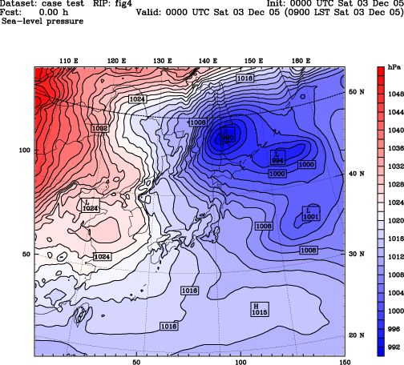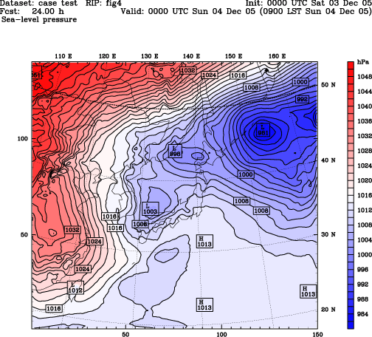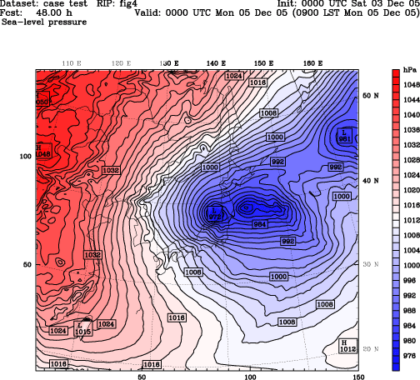

Figure 3. Simulated sea level pressure from the outer domain. (a) 09 JST December 3, (b) 09 JST December 4, and (c) 09 JST December 5.

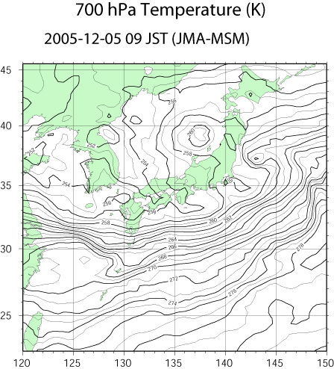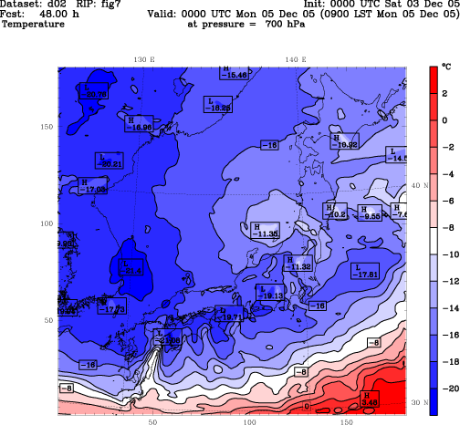

Figure 4. Spatial distribution of the 700 hPa temperature at 09 JST December 5, 2005, (a) derived from the JMA mesoscale analysis data and (b) the WRF model.

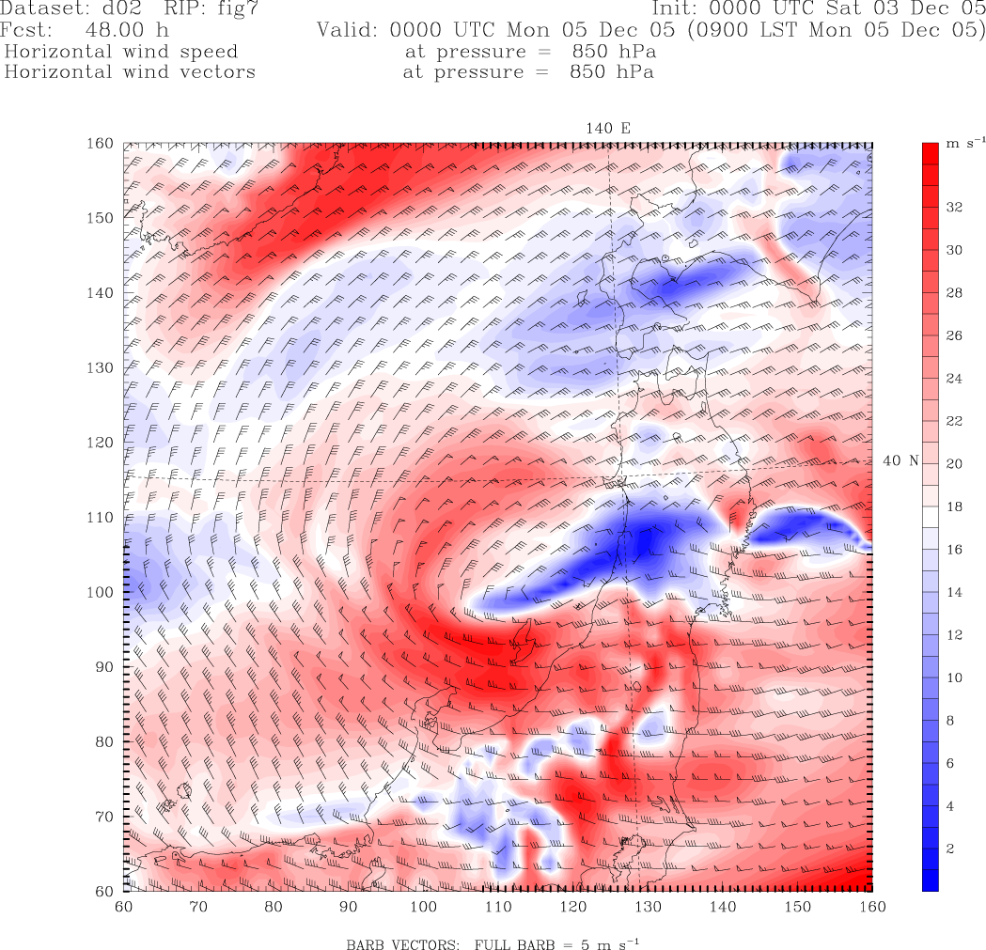

Figure 5. Simulated wind field at 850 hPa level at 09 JST December 5. Color contour indicates wind speed.

